**Progress Report**

***Work Completed*:**

Progress update on our ongoing project, the Doctor Management System. Throughout the reporting period, our team has achieved significant milestones across various project phases. We began by meticulously gathering information, conducting thorough research, and engaging with stakeholders to define clear project objectives and requirements. Subsequently, we developed and documented the essential business rules that govern the system's operations, ensuring alignment with industry standards and best practices.

Building upon this foundation, we proceeded to construct an Entity-Relationship Diagram (ERD) that visually represents the relationships between different entities within the system. This ERD serves as a blueprint for the system's data structure, enabling a deeper understanding of its underlying architecture. Additionally, we crafted a detailed Use Case Diagram that outlines various user interactions and scenarios, providing insights into the system's functionality from different user perspectives.

Furthermore, we have initiated development on the system's front end, focusing on designing and implementing an intuitive user interface. This phase marks a crucial step towards delivering a seamless and user-friendly experience for our end-users. As we move forward, our team remains dedicated to adhering to project timelines and milestones, ensuring the timely completion and successful implementation of the Doctor Management System.

***Work Remaining:***

Critical task on our agenda is the integration of the front-end with the backend components of the Doctor Management System. This phase involves bridging the gap between the user interface and the underlying system functionality, ensuring seamless communication and interaction between the two. Our team will focus on ensuring robust integration protocols and thoroughly testing the integrated system to identify and address any potential issues or inconsistencies.

Throughout these remaining tasks, we remain committed to upholding the highest standards of quality and efficiency. We will continue to collaborate closely, adhere to project timelines, and prioritize effective communication to ensure the successful completion and implementation of the Doctor Management System.

|  |  |  |
| --- | --- | --- |
| **Name** | **Work Assigned** | **Progress** |
| Muhammad Isam/Dua | ERD | Completed |
| Laiba Rehman | Bussiness Rules | Completed |
| Laiba Tariq | Prototype | Completed |
| Emad Tariq/ Sofia Haider | Front-end | In progress |
| Muhammad Isam | Backend | In-progress |

Unified ERD:

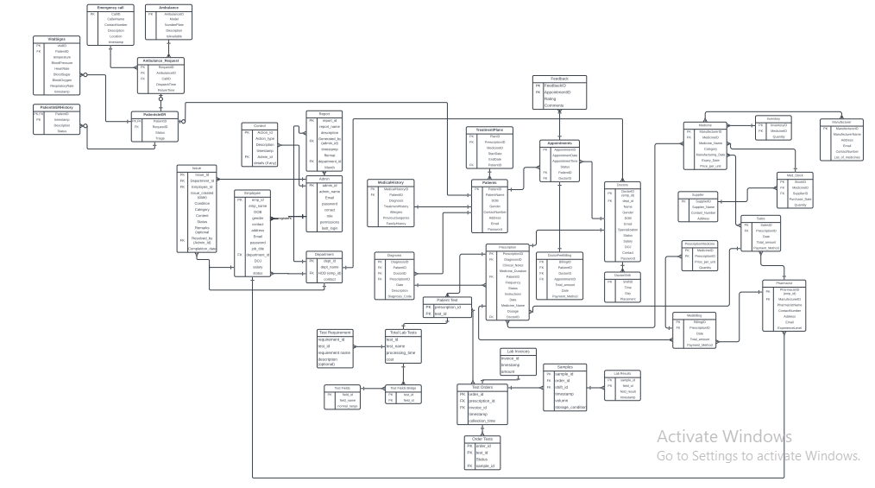

Bussiness rule:

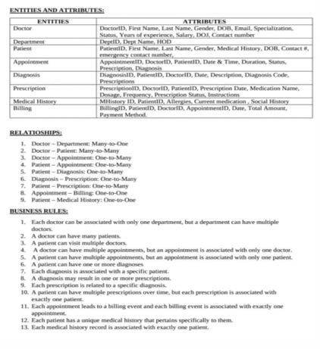

Front-End:

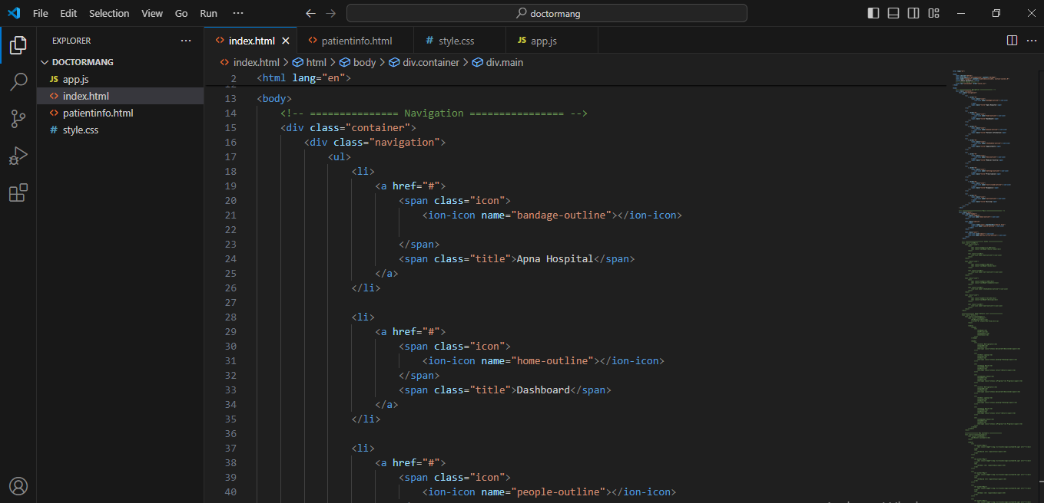

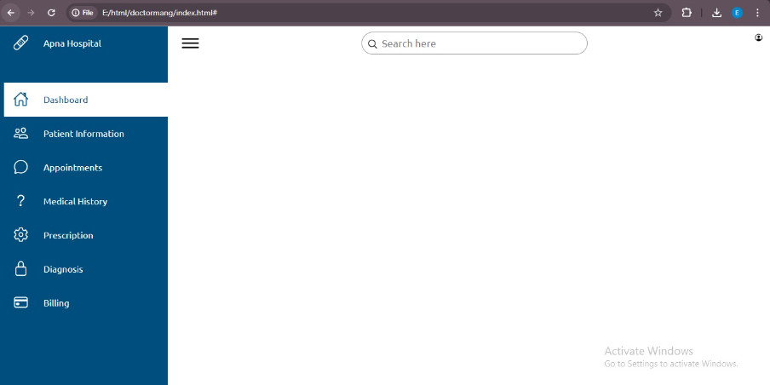

Jira:

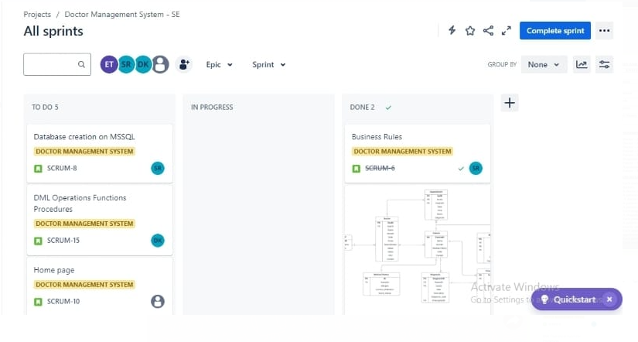

Github:

<https://github.com/Muhammad-Isam/Doctor-Management-System>

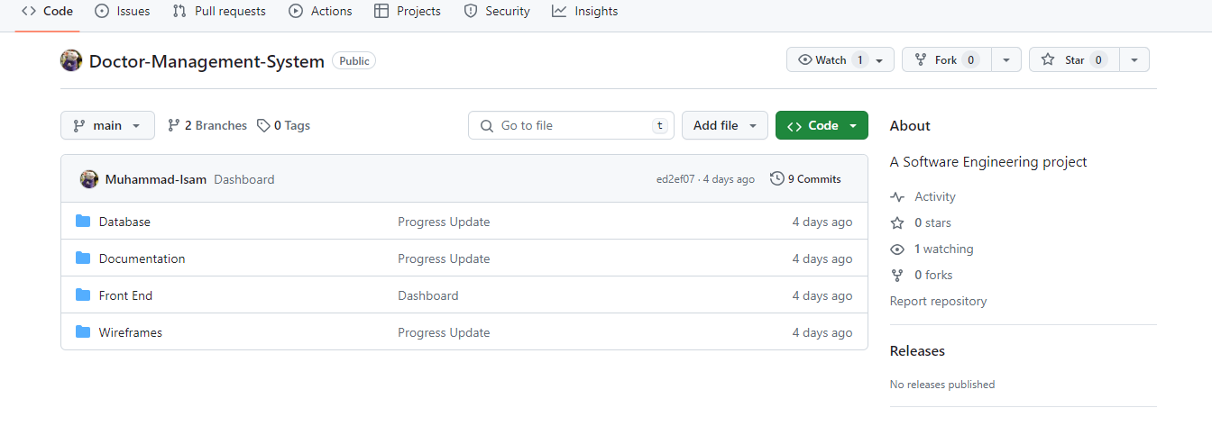

Use Case Diagram:

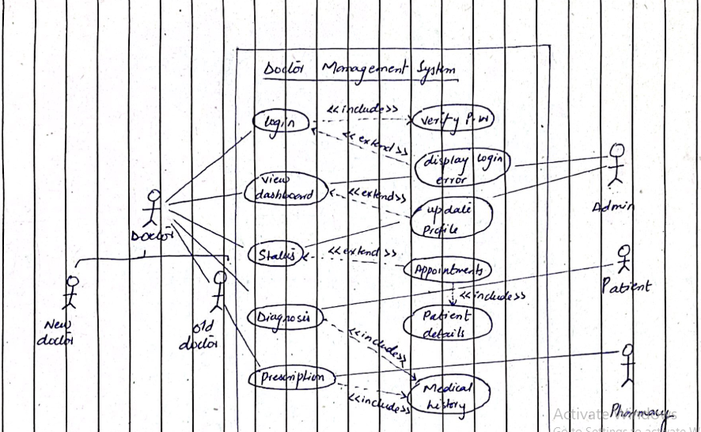

Backend:

